**English | Arabic (Main language to be english, with Arabic translation button that translates the entire website)  
  
Navigation** Home | About Us | Destinations | Services | Contact

—---------------------------------------------------------

**HOME**

**Hero Section**

* Title: UNITOPIA GLOBAL.
* Slogan: Your Path. Our Mission.

**Trust/Stats Bar**

* 4 years of experience

**Supportive Tagline**

* Helping Students From Application to Arrival
* Subtext: From applications to airport arrivals... Trust, clarity, and care are at the heart of every step we take together.

**Core Services (Four-Step System)**

1. Academic Pathway Guidance: We help students choose the right school subjects, majors, and universities based on academic background, personal interests, budget, and future career goals. Each plan is tailored, ensuring every student follows a pathway that leads to long-term success.
2. Application & Document Assistance: From drafting and refining personal statements to preparing supporting documents, our team handles every part of the application process. We ensure each submission is accurate, compelling, and on time, giving students the best chance at acceptance.
3. Visa & Pre-Departure Support: We guide students through visa applications, interview preparation, and required documentation. Beyond the visa, we provide orientation on travel, accommodation, and settling in abroad—helping families feel confident about every step.
4. Scholarship & Financing Assistance: We connect students with available scholarships, grants, and funding opportunities that match their profile. Our support includes guidance on scholarship essays, financial planning, and cost-of-living preparation, so studying abroad is both achievable and sustainable.

For the home section, a preview of each page. Short about us section with a button that takes you to the about us section. And a destinations section, which shows a list of the countries (UK, USA, SPAIN, CANADA, EUROPE). The Services section is also on the home page, which includes an accordion, for example, free consultation, apply with us now, etc. And a section for the contact page is also on the home page, which also has like “Have any further questions? Contact us, with a button that takes us to the contact page”.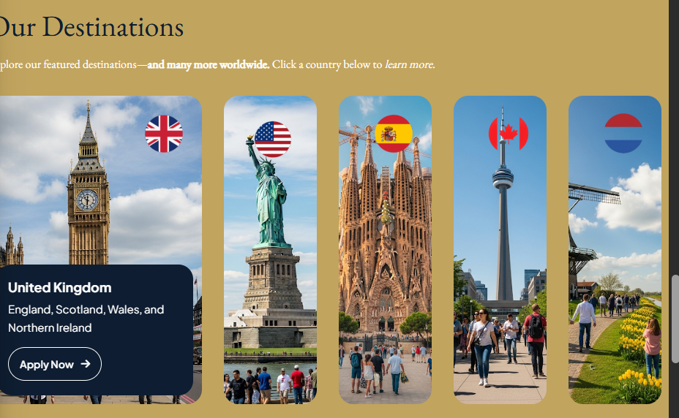  
  
Finally, I want to have a section on the home page for this Discord hyperlink <https://discord.gg/AUA9mehY> for the students to join the community.  
  
**Final Call-to-Action Banner**

**Option 1:** Need expert support for university applications and visas? Ready to embark on your journey abroad?

**Option 2 (simpler):** Have a dream university in mind? Let’s make it happen together.

**CTA Button:** [Book a Free Consultation]

**Design:** Full-width banner in navy blue with gold CTA button.

—----------------------------------------------------------------------------------------------

# **About Us – Detailed Documentation**

### **1. Hero Section**

**Title:** The Story Behind Unitopia Global  
 **Subtitle:** Unitopia Global is a Saudi-based consultancy guiding ambitious students from application to arrival.  
 **Design:** Simple, clean header with your logo watermark in the background.

### **2. Mission & Vision**

**Mission Statement** To guide and support Middle Eastern students—through personalized advising, application expertise, and visa assistance—so each individual can achieve an outstanding international education and seamless transition abroad.

**Vision Statement** To become the region’s most trusted study-abroad partner, known for transforming students’ aspirations into global opportunities with clarity, integrity, and genuine care.

**Design:** 2-column section (Mission left, Vision right) with icons (compass for mission, telescope for vision).

### **3. Welcome Letter (Personal Message)**

**Headline:** A Message to Our Students  
 **Text:**

Dear Student,

Deciding to pursue education abroad involves far more than selecting a university—it represents a significant step toward your future, independence, and aspirations, and it is natural to feel both exhilarated and uncertain.

At Unitopia Global, the mission extends beyond managing applications. Every conversation begins with attentive listening to understand individual goals and concerns, offering guidance grounded in integrity and expertise, much like a trusted mentor would.

Each student’s journey is treated with the same dedication and personal care that we would expect for ourselves. Whether still exploring options or ready to move forward, support is unwavering—celebrating achievements and providing steady encouragement through every challenge.

You need not face this alone. Confidence in your potential is at the heart of our commitment, and we look forward to helping transform dreams into reality.

With sincere dedication,  
 **The Unitopia Global Team**

**Design:** Place this inside a styled card or box with a subtle background color and maybe a side portrait of a student.

### **4. Core Values**

**Headline:** Principles That Guide Every Step  
 **Values (Cards):**

1. **Transparency** – Open, honest guidance at every stage
2. **Integrity** – Always acting in students’ best interest
3. **Student-First** – Personalized plans, never one-size-fits-all
4. **Excellence** – Premium service with measurable results

**Design:** 4-column card layout with icons (eye, shield, person, trophy).

### **5. Our Process Overview**

**Headline:** How We Work  
 **4 Steps:**

1. **Consult** – Understand goals, grades, and budget.
2. **Plan** – Map out majors, destinations, and timelines.
3. **Apply** – Prepare documents, essays, and applications.
4. **Depart** – Visa prep, accommodation guidance, pre-departure briefing.

**Design:** Timeline/stepper visual with icons for each stage.

### **6. Community Invite (Optional Section)**

**Headline:** Not Just a Consultancy — A Community  
 **Text:** We believe in building lasting connections. Students are invited to join our Discord community to connect with peers, ask questions, and build friendships before even arriving abroad.  
 **CTA Button:** [Join Our Discord]

### **7. Final CTA**

**Headline:** Ready to Begin Your Journey?  
 **Subtext:** Let us help you turn your goals into a global education experience.  
 **CTA Button:** [Book a Free Consultation]

_________________________________________________________

### **Contact Form**

**Fields to Include:**

* Full Name
* Email Address
* Phone Number (optional but encouraged)
* Country of Interest (dropdown or free field)
* Message / Inquiry

**Submit Button Text:** Send My Message (instead of generic “Submit”).

Developer note: make sure the form sends responses directly to your company email (admin@unitopiaglobal.com) and includes a confirmation “Thank you” message.

### **3. Direct Contact Information**

**Block with clear icons (phone, email, map pin):**

* **Email:** admin@unitopiaglobal.com
* **Phone / WhatsApp:** +966 54 515 0572
* **Location:** Riyadh, Saudi Arabia

**Design Tip:** Place next to the form in a 2-column layout (Form on left, Contact Info on right).

### **4. Map Embed (Optional but Professional)**

Embed a Google Map of Riyadh for credibility. If you don’t want to show a precise street address yet, you can just center the map on “Riyadh, Saudi Arabia.”

### **5. FAQ Section**

Add a small accordion right under the form:

**Title:** Frequently Asked Questions

**Questions & Answers:**

1. **Do I need to have a university chosen before contacting you?**

**No. Many students come to us still exploring options. We’ll help guide the decision.**

_________________________________________________________________________

1. **Can you still help if I already applied on my own?**

**Yes, we can step in at any stage to review, advise, and provide additional support.**

________________________________________________________________________

**1. When should I start applying to universities abroad?   
Applications should be started at least 12 months in advance to allow time for choosing the right university, preparing documents, and meeting deadlines. Starting early increases your chances of securing admission and scholarships.**

**2. What are the language requirements for studying abroad?  
 Most universities require proof of English proficiency, such as IELTS or TOEFL. Minimum scores vary depending on the country and program, but typically range from IELTS 5.5–7.0 or TOEFL 70–100.**

**3. Do I need to take the SAT, ACT, or any entrance exam?  
 It depends on the country and university. U.S. universities often require SAT or ACT, while others (like the UK) may not. Some programs (e.g., medicine, law) have additional exams.**

**4. What documents do I need to apply?  
 Commonly required documents include:**

* **Passport copy**
* **Academic transcripts and certificates**
* **English test results (IELTS/TOEFL)**
* **Statement of Purpose / Personal Statement**
* **Letters of recommendation**
* **CV/Resume (for postgraduate)**

**5. Can I apply if my English level is not strong yet?  
 Yes. Many universities offer foundation or pathway programs where students improve their English before starting the degree. Some schools also allow conditional offers if you are still completing your English exam.**

**6. How many universities can I apply to?  
 There is no fixed limit, but we recommend applying to 4–6 universities: a mix of safe, target, and dream options. This balances your chances of admission with your preferred choices.**

**7. What is a foundation or pathway program?  
 A foundation or pathway program is a one-year preparation course designed for international students. It helps improve English and academic skills so students can smoothly transition into their chosen degree.**

**8. What is a Statement of Purpose or Personal Statement?  
 A Statement of Purpose (SOP) or Personal Statement is a short essay where students explain their academic goals, career ambitions, and reasons for choosing a specific program/university. It is often a key factor in admissions decisions.**

### **Placement**

* **Place this section below the contact form on the Contact Page.**
* **End with a short line like:  
   “Didn’t find your question? Reach out directly using the form above.”**

____________________________________________________________________________

**Services Page – Conversion-Oriented Layout**

### **1. Hero Section**

* **Title: Our Comprehensive Services**
* **Subtitle: Everything you need for a smooth study abroad journey, from your first consultation to your first day on campus.**
* **Background: clean, professional (students + consultants).**

### **2. Service Blocks (Detailed)**

**(Same 4 services explained, since this page must showcase them — but not in excessive depth, just enough detail to establish credibility.)**

* **Academic Pathway Guidance**
* **Application & Document Assistance**
* **Visa & Pre-Departure Support**
* **Scholarship & Financing Assistance**

**Each with an icon, short headline, and 2–3 lines description.**

### **3. Get a Free Consultation Section**

* **Headline: Not sure where to start?**
* **Subtext: Book a free consultation with one of our advisors and get clear guidance tailored to your goals.**
* **CTA Button: [Book My Free Consultation]**
* **Visual: Smiling student with consultant, or a calendar/booking-style graphic.**

### **4. Apply With Us Section**

* **Headline: Don’t Miss Out on Your Dream University**
* **Subtext: Admissions deadlines move quickly. Apply with Unitopia Global today and secure your place before it’s too late.**
* **CTA Button: [Apply Now]**
* **Visual: Students celebrating with acceptance letters.**

### **5. Our Promise Section (Trust Builder)**

* **Headline: Why Choose Unitopia Global?**
* **Text: We believe in transparent, personalized, and reliable guidance. Every application is treated with the same care as if it were our own.**
* **3–4 quick trust badges/icons ( Transparency, Student-First, Visa Support, Ongoing Help).**

### **6. Final Call to Action**

* **Headline: Ready to Take the First Step?**
* **Subtext: Whether you’re still exploring options or ready to apply, our team is here to help.**
* **CTA: [Book Free Consultation]**

**________________________________________________________________________**

# **Destinations Page – Documentation**

### **1. Hero Section**

* **Title: Explore Our Study Destinations**
* **Subtitle: From the US to Europe, discover the world’s top universities and opportunities.**
* **Design: World map or collage of landmarks (Big Ben, Statue of Liberty, CN Tower, Spanish architecture, Bosphorus).**

### **2. Featured Countries List (Main Page)**

**Each country should appear as a clickable icon/card.  
 When clicked → leads to its sub-page.**

* **🇺🇸 United States**
* **🇨🇦 Canada**
* **🇬🇧 United Kingdom**
* **🇪🇸 Spain**
* **🇪🇺 Europe (Other) → Netherlands, Ireland, etc.**
* **🇹🇷 Turkey**

**Additional Element:**

* **A hyperlink under the section:  
   “See the latest QS World University Rankings →” (opens in new tab).**

### **3. Country Sub-Pages**

**Each sub-page will follow the same structure:**

**Example: United States**

* **Hero Image: City or campus photo (e.g. New York skyline + students on campus).**
* **Intro Description:  
   The United States is home to many of the world’s top-ranked universities. Known for its flexible programs and diverse campuses, the US attracts international students seeking cutting-edge education and cultural variety.**
* **Most Popular Universities (3–5 Examples):**
  + **Harvard University**
  + **MIT**
  + **Stanford University**
  + **UCLA**
  + **NYU**

**(Show each with a small image or logo, 1–2 sentence description, and a “Explore University” link that opens their campus page or official site.)**

* **Why Study Here (Small Box):  
   Innovative research, multicultural environment, and career opportunities after graduation.**
* **Apply Now (CTA Section):**
  + **Text: Ready to study in the USA? Apply now through Unitopia Global.**
  + **CTA Button: [Apply Now → Contact Page]**

**Repeat the same structure for each country:**

### **🇨🇦 Canada**

* **Safe, multicultural campuses, post-graduation work opportunities.**
* **Popular universities: University of Toronto, McGill, UBC, University of Waterloo.**

### **🇬🇧 United Kingdom**

* **3-year bachelor’s, global reputation, historic campuses.**
* **Popular universities: Oxford, Cambridge, Imperial College, LSE, UCL.**

### **🇪🇸 Spain**

* **Affordable tuition, English-taught programs, rich lifestyle.**
* **Popular universities: IE University, University of Barcelona, ESADE, Universidad Autónoma de Madrid.**

### **🇪🇺 Europe (Other)**

* **Netherlands, Ireland, Germany, etc.**
* **Shorter degree programs, strong industry links.**
* **Popular universities: University of Amsterdam, Trinity College Dublin, LMU Munich.**

### **🇹🇷 Turkey**

* **Affordable programs, cultural familiarity, English options.**
* **Popular universities: Koç University, Sabancı University, Bilkent University, Istanbul University.**

### **4. Final CTA Banner (at the end of Destinations Page)**

* **Headline: Where will your journey take you?**
* **Subline: Explore universities worldwide with Unitopia Global. Apply today and secure your future.**
* **CTA Button: [Book Free Consultation]**